Jetson Orin Platform

**Feature:**

* Support nVidia Jetson Orin NX/NANO series
* HDMI® 2.1 (NX)/1.4 (NANO)
* 2 x MISI CSI connector
* 1 x GbE (POE opt.) & 1 x 2.5GbE (POE opt.)
* 1x M.2 Key-M & 1 x M.2 Key-E & 1 x M.2 Key-B
* 4 x 3.2 USB type A
* 1 x RS232/CAN & 1 x RS232/422/485
* Linux, JetPack 6.2

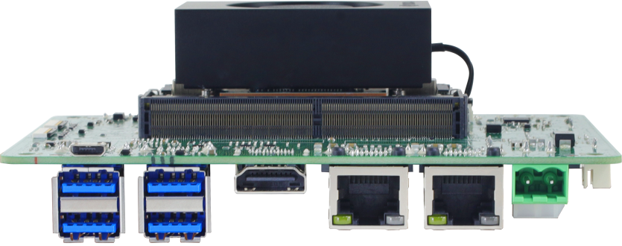

**Specification:**

|  |  |  |  |  |
| --- | --- | --- | --- | --- |
| **Model Name** | **AI-NONXS** | | | |
| **nVidia Module** | **Jetson Orin NX 16GB** | **Jetson Orin NX 8GB** | **Jetson Orin Nano 8GB** | **Jetson Orin Nano 4GB** |
| **AI Performance** | 100 TOPS | 70 TOPS | 40 TOPS | 20 TOPS |
| **GPU** | 1024-core NVIDIA Ampere architecture GPU with 32 Tensor Cores | | 1024-core NVIDIA Ampere architecture GPU with 32 Tensor Cores | 512-core NVIDIA Ampere architecture GPU with 16 Tensor Cores |
| **CPU** | 8-core Arm® Cortex®-A78AE v8.2 64-bit CPU | 6-core Arm® Cortex®-A78AE v8.2 64-bit CPU | 6-core Arm® Cortex®-A78AE v8.2 64-bit CPU | |
| **Memory** | 16GB 128-bit LPDDR5 102.4GB/s | 8GB 128-bit LPDDR5 102.4GB/s | 8GB 128-bit LPDDR5 68GB/s | 4GB 64-bit LPDDR5  34GB/s |
| **HDMI®** | 2.1 | | 1.4 | |
| **Audio** | 1 x 3.5mm Headset jack with Line-out/MIC-In  1 x digital MIC pin header, 1 x speaker out pin header | | | |
| **MIPI Camera** | |  | | --- | | 2 x 4-lane MIPI CSI with 22-pin connector | | | | |
| **Ethernet** | 1 x GbE (POE opt.), 1 x 2.5GbE (POE opt.) | | | |
| **USB** | 4 x USB 3.2 type A & 1 x Micro USB (for OS flash) | | | |
| **Storage** | 1 x M.2 Key-M PCIe Gen.4 x4 2242/2260/2280  NVMe SSD | | 1 x M.2 Key-M PCIe Gen.3 x4 2242/2260/2280  NVMe SSD | |
| **Expansion** | 1 x M.2 Key-E for 2230 Wi-Fi & BT module  1 x M.2 Key-B for 3042/3052 4G LTE/5G module  1 x Nano SIM slot | | | |
| **Serial Port** | 1 x RS232/CAN & 1 x RS232/422/485 | | | |
| **(Expansion I/O** | 1 x 14-pin header: SPI, I2C, GND, 3.3V, 5V | | | |
| **Others** | 1 x 12-pin header: LED, 5V, UART, LATCH (AT/ATX mode switch), GND, RST, RCV, PWR | | | |
| **Fan** | 1 x 4-pin header | | | |
| **RTC** | 1 x 2pin header | | | |
| **Security (Opt.)** | TPM 2.0 | | | |
| **Button** | 1 x Power On button , 1 x Recovery button, 1 x Reset button | | | |
| **Power Input**  **Connector** | 1 x DC Power Jack for 12V~20V  1 x 2-pin internal power connector | | | |
| **Dimension** | 130mm x 100mm | | | |
| **Operation Temp.** | -20~60 | | | |
| **OS** | Linux, JetPack 6.2  Support Jetson Orin NX/Nano modules (Super Mode-enabled) | | | |

**Jetson Orin module with Super mode performance:**

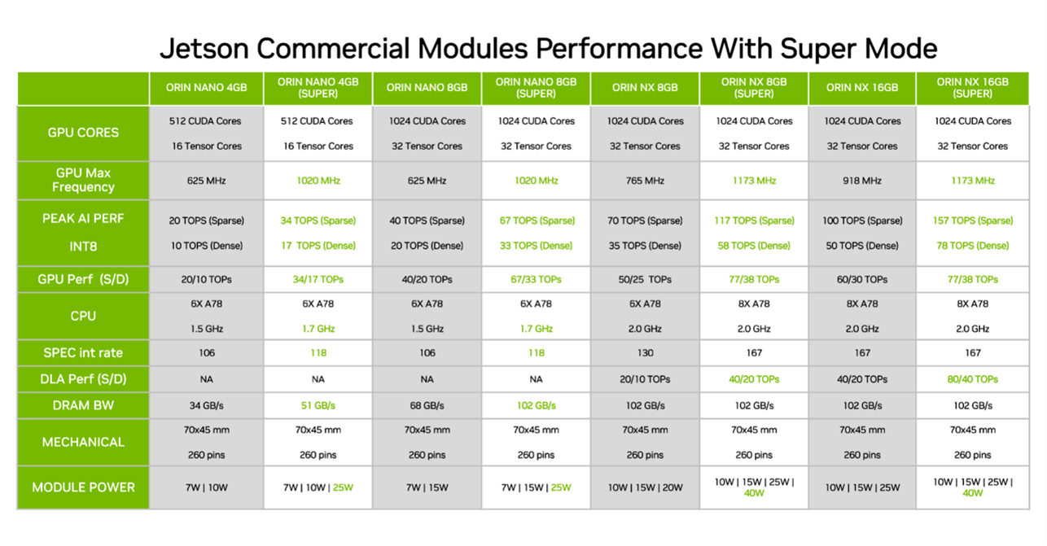

**I/O Information:**

