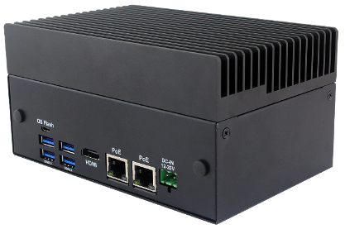
EdgeComp AI-NONXS
Fanless Edge AI Application System

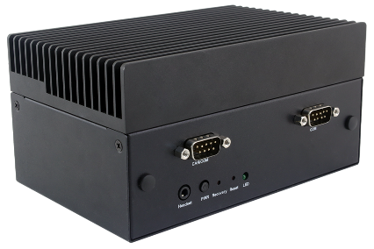

Key features
- Compact fanless design.
- Support NVIDIA Jetson Orin NX and Orin Nano (Super Mode) module.
- 1 x M.2 Key-M 2242/2260/2280 NVMe SSD.
- 1 x M.2 Key-B for 4G/5G module, 1 x M.2 key-E for WiFi & BT.
- 1 x GbE LAN, 1 x 2.5 GbE LAN. ( PoE opt.)
- 1 x RS232/CAN, 1 x RS232/422/485
- 12 to 20V DC input.

Specifications
Model Name | EdgeComp AI-NONXS
NVIDIA Module | Jetson Orin NX 16GB | Jetson Orin NX 8GB | Jetson Orin Nano 8GB | Jetson Orin Nano 4GB
AI Performance | 100 TOPS | 70 TOPS | 40 TOPS | 20 TOPS
GPU | 1024-core NVIDIA Ampere architecture GPU with 32 Tensor Cores |  | 1024-core NVIDIA Ampere architecture GPU with 32 Tensor Cores | 512-core NVIDIA Ampere architecture GPU with 16 Tensor Cores
CPU | 8-core Arm® Cortex®-A78AE v8.2 64-bit CPU | 6-core Arm® Cortex®-A78AE v8.2 64-bit CPU | 6-core Arm® Cortex®-A78AE v8.2 64-bit CPU
Memory | 16GB 128-bit LPDDR5 102.4GB/s | 8GB 128-bit LPDDR5 102.4GB/s | 8GB 128-bit LPDDR5 68GB/s | 4GB 64-bit LPDDR5 34GB/s
HDMI | 2.1 |  | 1.4
Audio | 1 x 3.5mm Headset jack with Line-out/MIC-In
Ethernet | 1 x GbE (POE opt.), 1 x 2.5GbE (POE opt.)
USB | 4 x USB 3.2 type A & 1 x Micro USB (for OS flash)
Storage | 1 x M.2 Key-M 2242/2260/2280 NVMe SSD
Expansion | 1 x M.2 Key-E for 2230 Wi-Fi & BT module  1 x M.2 Key-B for 3042/3052 4G LTE/5G module  1 x Nano SIM slot
Serial Port | 1 x RS232/CAN, 1 x RS232/422/485
Button | 1 x Power On button , 1 x Recovery button, 1 x Reset button
Power Input | DC-IN 12V~20V / 2-Pin Terminal Black
Dimension | 160 x 102 x 80 mm ( W x D x H )
Operation Temp. | -20~50 ℃
OS | Linux, Jetpack 6.2  Support Jetson Orin NX/Nano modules (Super Mode-enabled)
Dimensions & I/O :
